Class : XII CYCLE TEST-2 Date: 29.08.19
Subject: CHEMISTRY Marks: 20
1. For the reaction: 2A + B → A₂B the rate = k[A][B]² with k = 2.0 × 10⁻⁶ mol⁻² L ² s ⁻¹ .
Calculate the initial rate of the reaction when [A] = 0.1 mol L⁻¹, [B] = 0.2 mol L⁻¹.
Calculate the rate of reaction after [A] is reduced to 0.06 mol L⁻¹. (2)
2. The decomposition of NH₃ on platinum surface is zero order reaction.
What are the rates of production of N₂ and H₂ if k = 2.5 × 10⁻⁴ mol⁻¹ L s⁻¹? (2)
3. A reaction is second order with respect to a reactant. How is the rate of reaction
affected if the concentration of the reactant is (i) doubled (ii) reduced to half? (3)
4. What is the effect of temperature on the rate constant of a reaction?
How can this temperature effect on rate constant be represented quantitatively? (2)
5. Calculate the half-life of a first order reaction from their rate constants given below:
(a) 200 s⁻¹ (b) 2 min⁻¹ (3)

6. In a pseudo first order hydrolysis of ester in water, the following results were obtained:
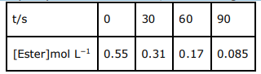
(a) Calculate the average rate of reaction between the time intervals 30 to 60 seconds.
(b) Calculate the pseudo first order rate constant for the hydrolysis of ester. (3)
7. In a reaction between A and B, the initial rate of reaction (r₀) was measured for
different initial concentrations of A and B as given below:
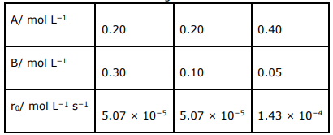
What is the order of the reaction with respect to A and B? (5)

